Video Playback of an Alarm Demo Project Setup

Contents
Install Requirements 1
Section A – Setting up Vision Stream Playback 1
Section B – Setting up files and file paths needed for video playback functionality 2

Install Requirements
TwinCAT 4024.22+
TC HMI
TC Vision
Scope

Section A – Setting up Vision Stream Playback
TwinCAT project and HMI project are in archive file: TcVis_ShapeColor_stream_Solution.tnzip
To use sample, need to unzip TcVis_ShapeColor_Streams+contours.zip and place them in C:\Users\Public\TcVision\
If changing location, will need to change in 2 locations:

- In PLC Main declaration:

- In Streams playback folder location
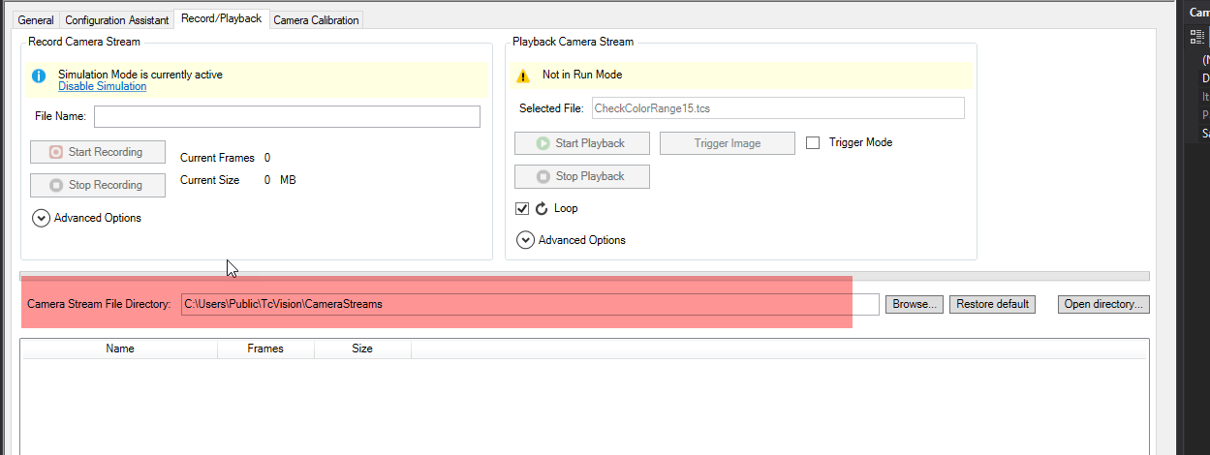

Section B – Setting up files and file paths needed for video playback functionality

Paths needed to be defined
Alias used in this Doc | Description
<VideoPath>
<ScopeImageExportPath>

